**The British College**

**KATHMANDU**

**Coursework Submission Coversheet**(individual coursework only)

**Faculty of Arts, Environment and Technology LBU Student Id:**

C7202333

**For checking by the student:**

Please ensure all information is complete and correct and attach this form securely to the front of your work before posting it in a coursework collection box.

Award name: BSc Hons in Computing

Module code: COMP611

Module name: Advanced Software Engineering

Module run: 2020

Coursework title: Graphical Programming Language

Due Date: 24th Dec 2020

Module leader: (In LBU): Dr Duncan Mullier, Dr Muthu Ramachandran

Module tutor: (In TBC): Resham Bahadur Pun

**TURNITIN** Checked: YES NO ***(please circle)***

Submission date& time: Date: Time: Before noon

**Total Word Count: Total Number of Pages (including this front sheet):**

**In submitting this form with your assignment, you make the following declaration:**  
I declare, that the coursework submitted is my own work and has not (either in whole or part) been submitted towards the award of any other qualification either at LBU or elsewhere. I have fully attributed/referenced all sources of information used during the completion of my assignment, and I am aware that failure to do so constitutes an assessment offence.

Signed: Date: 24th Dec 2020

**You are strongly advised to retain a second copy of your work in case of any query about the assignment.**

**For completion by the faculty:**

**This mark is provisional and subject to moderation and approval by the relevant examining board**

**Teacher's Feedback**

**Teacher's Signature: __________________________________ Date: _________________**

**Table of Contents**

**Program Screenshot** 2

**Main Program (GUI)** 2

**Drawing Shapes** 3

**Adding Functionality** 7

**Checking Syntax Error** 8

**Draw Shape with defined variable, loop and method** 9

**Reading from File** 11

**About Us** 12

# **Program Screenshot**

## **Main Program (GUI)**

The Graphical User Interface of the DrawGeometryShape program. This is a GUI based application that reads and executes commands on command line one at a time. It also reads a program (in the program window) and executes it with a “run” command (typed into the command line). It saves and loads a program and syntax checking. Checks for valid commands and for valid parameters. clear command to clear the drawing area reset command to move pen to initial position at top left of the screen. This program is using inheritance and design patterns. Also, this program is written in C# language.

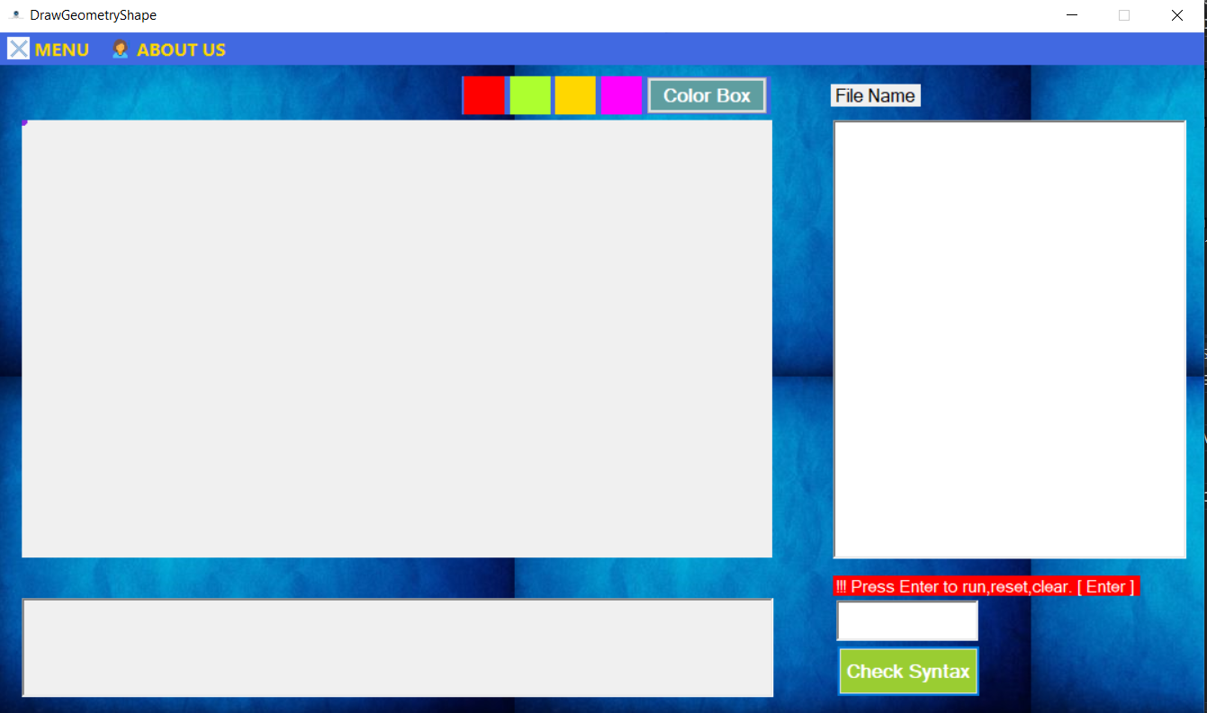

## **Drawing Shapes**

* Circle without filled color

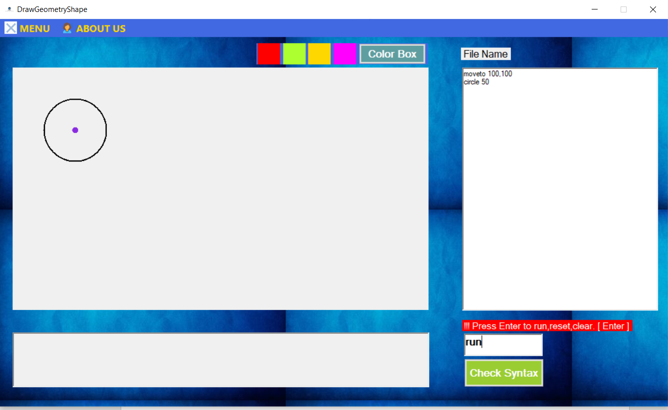

* Circle with filled color fill on

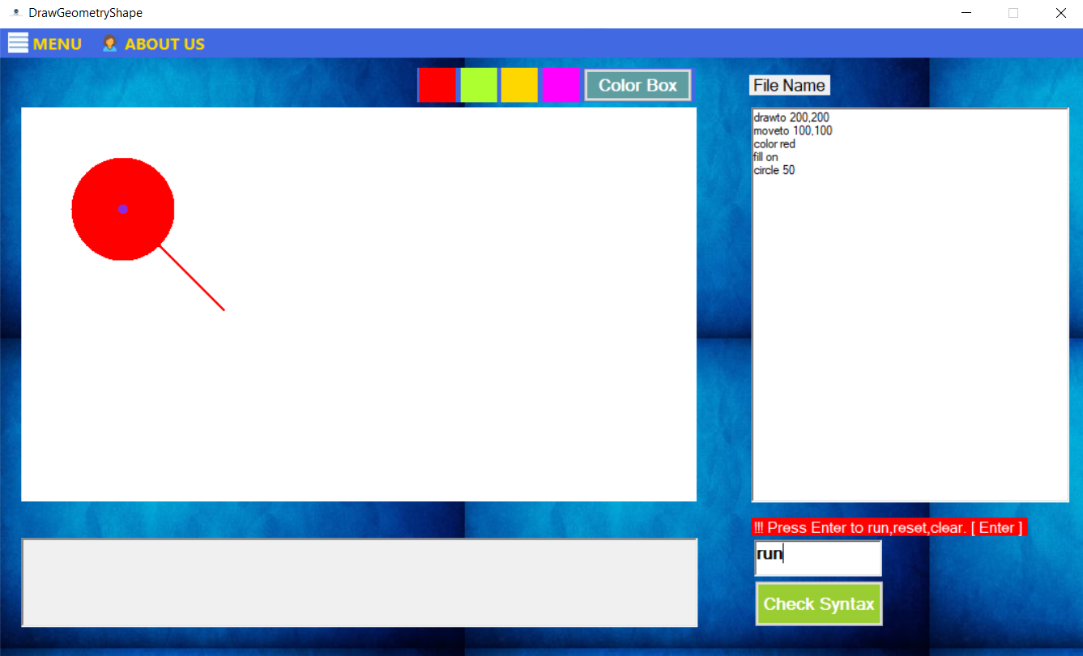

* Rectangle without filled color

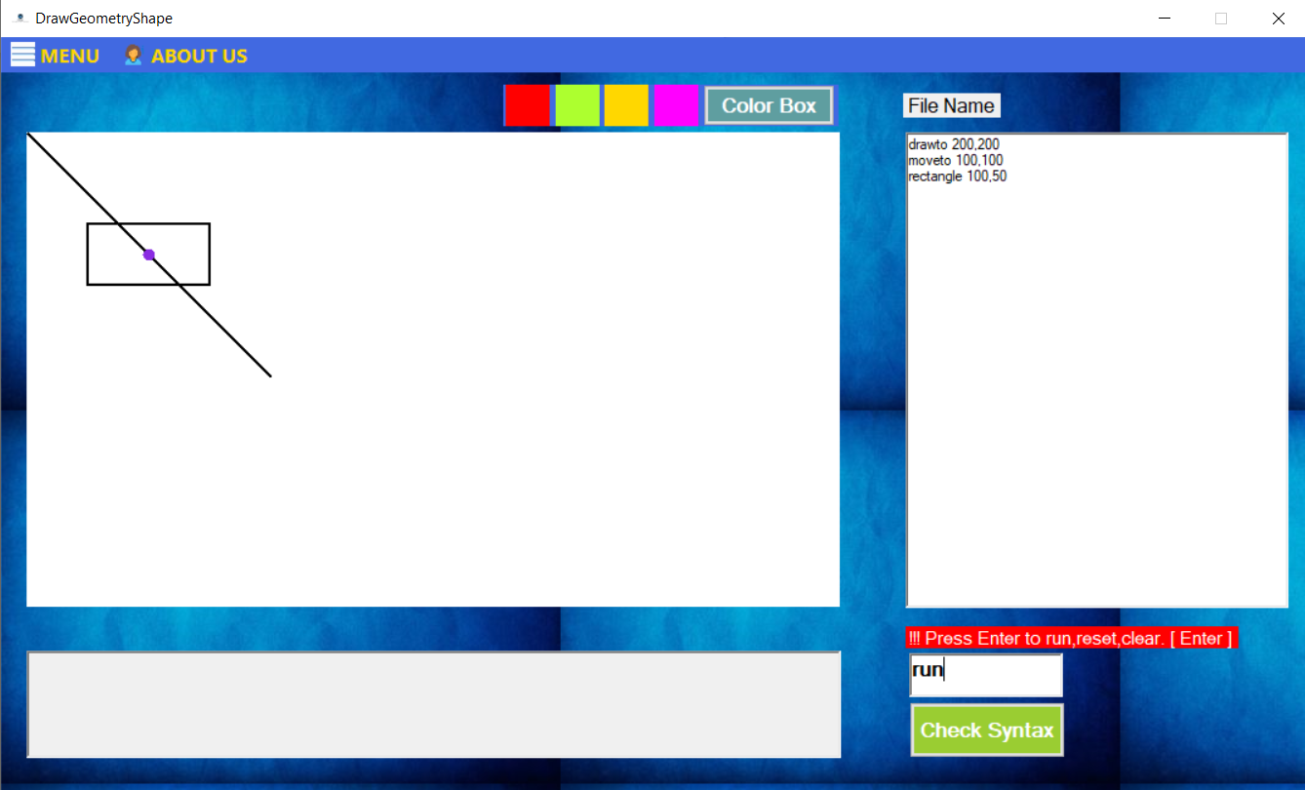

* Rectangle with filled color fill on

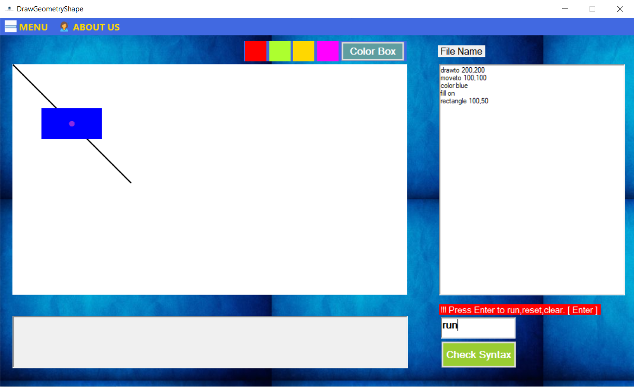

* Triangle without filled color

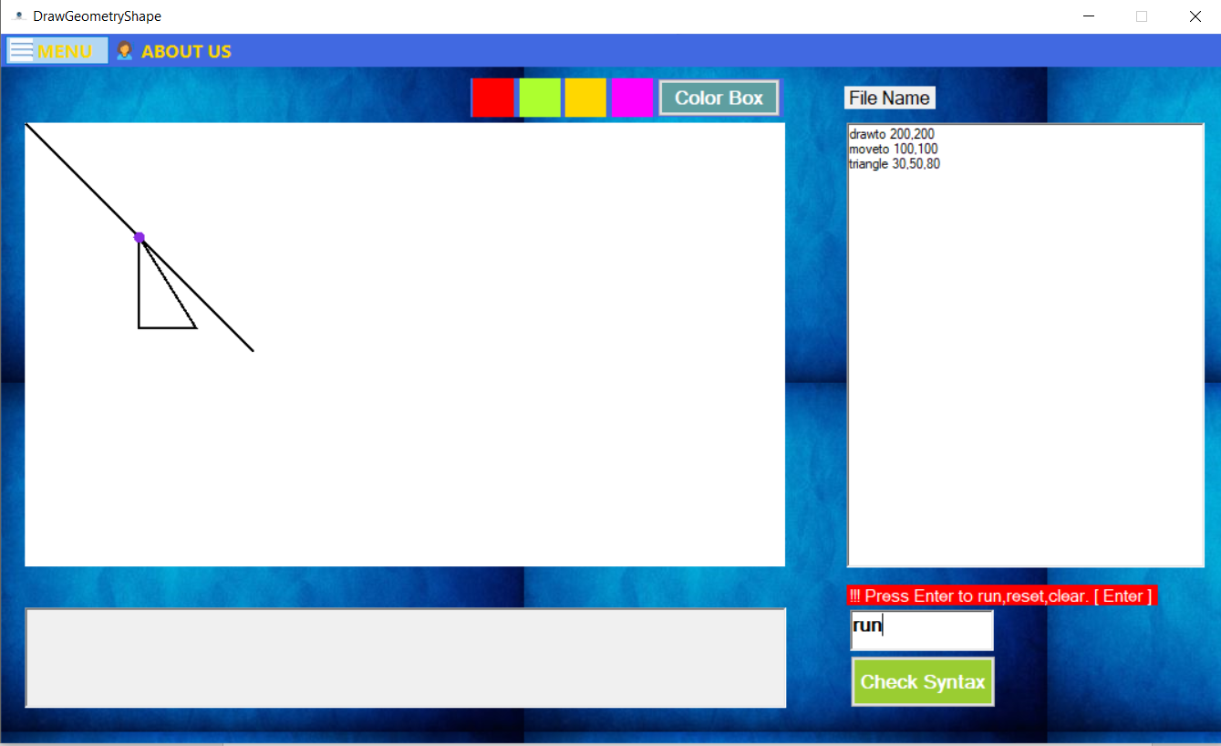

* Triangle with color filled on

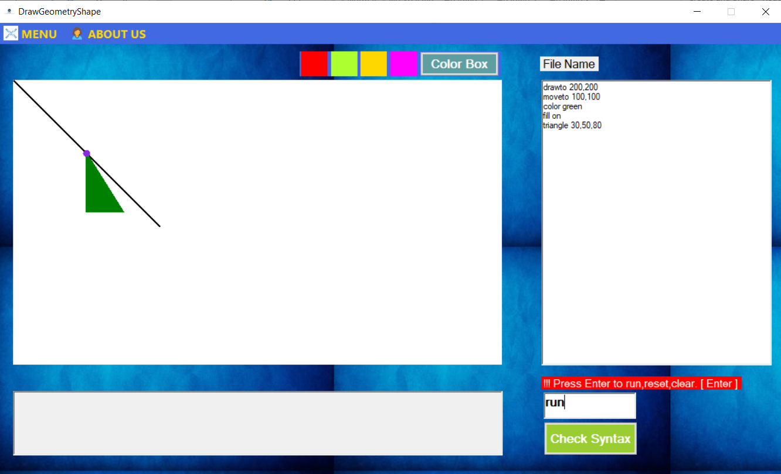

* Draw Line

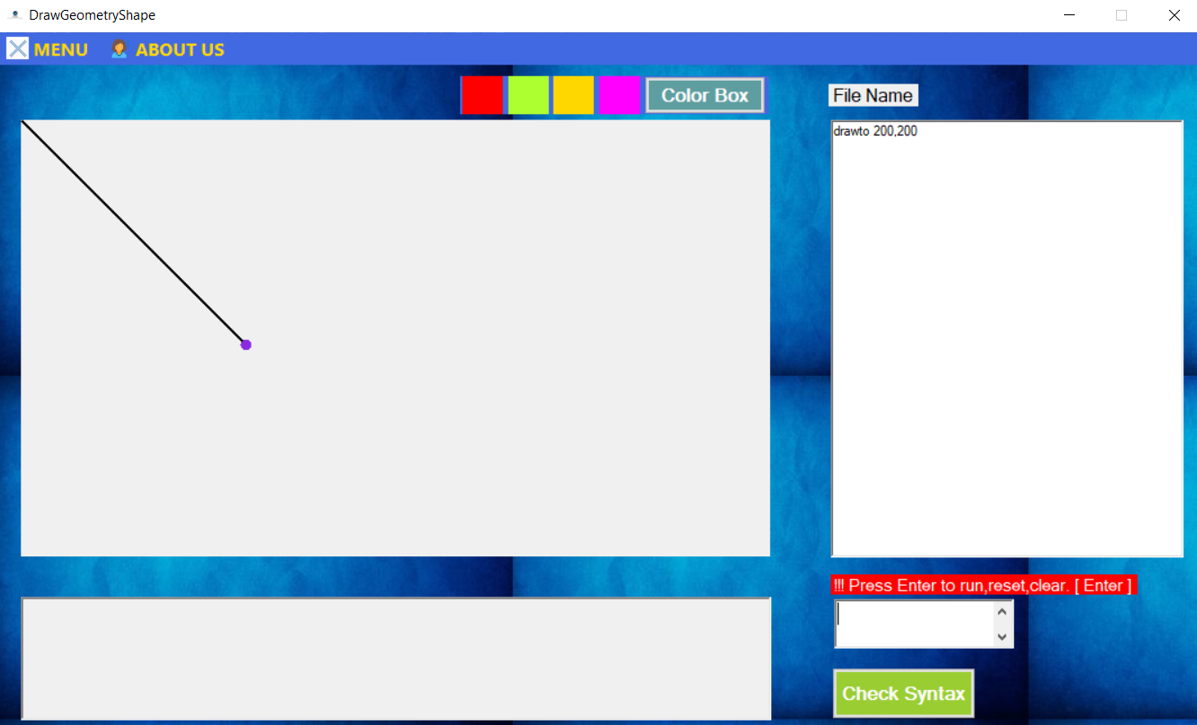

* Draw Multi Line

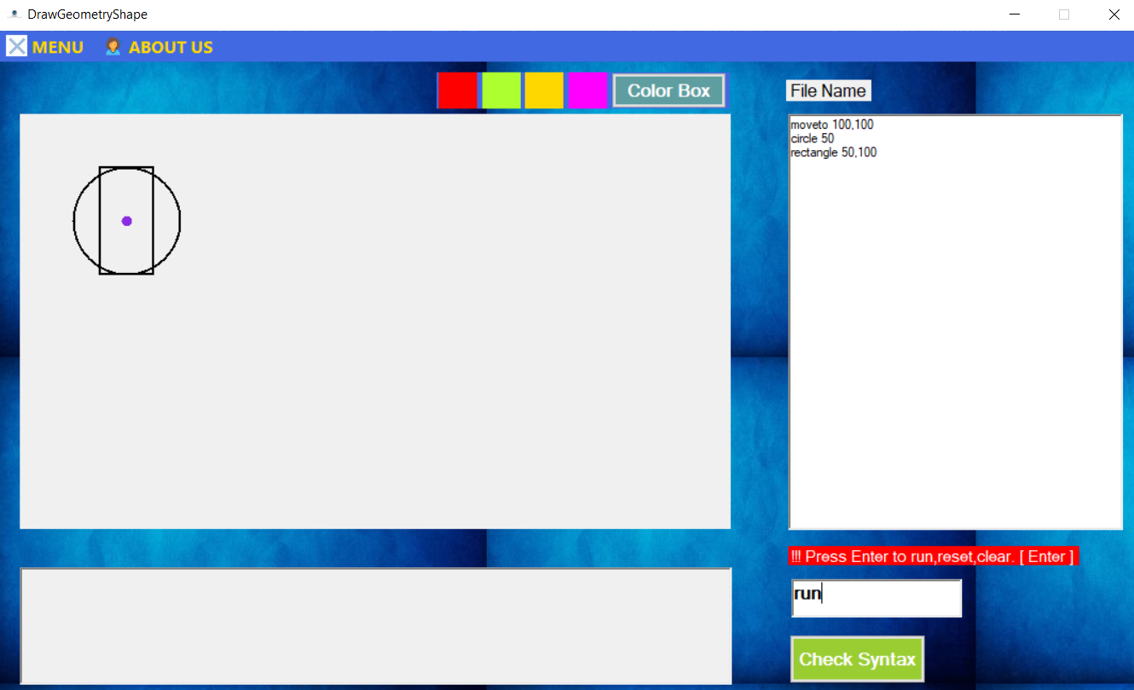

## **Adding Functionality**

* Adding new shape in the project

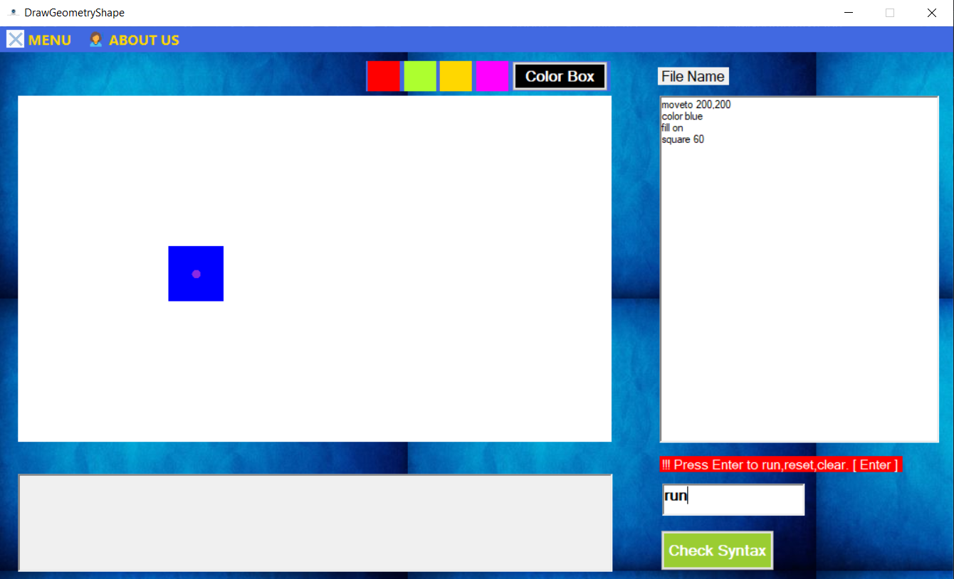

* Adding New Color Draw Line

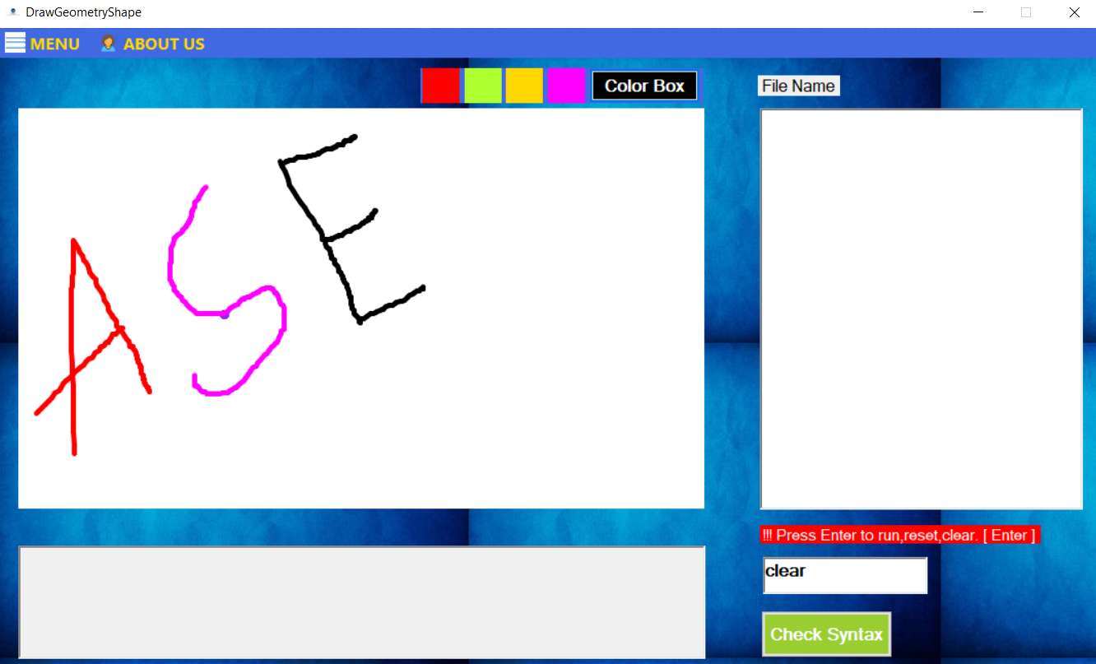

## **Checking Syntax Error**

* Wrong Parameter

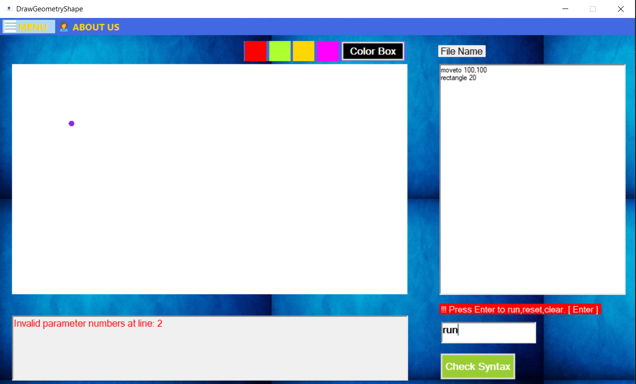

* Right Parameter with Wrong line

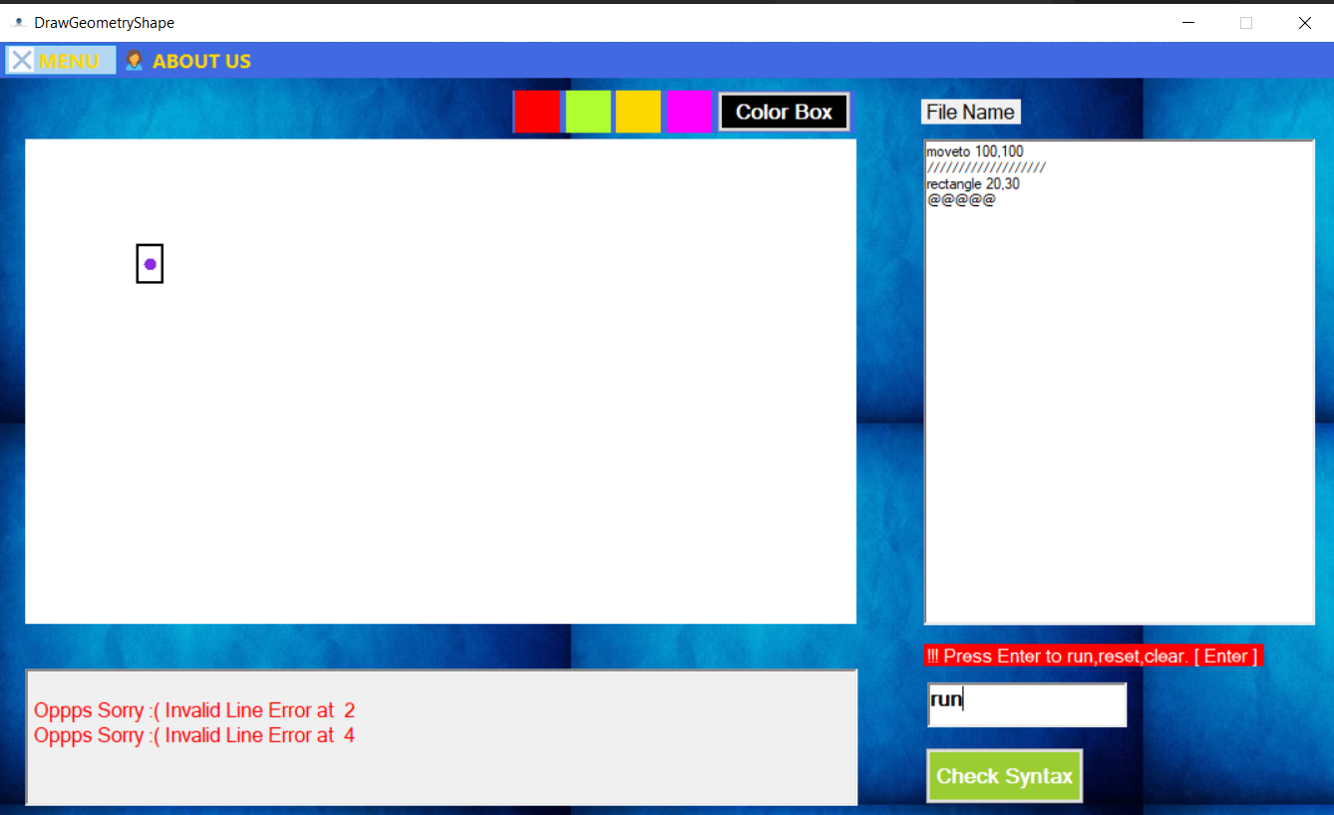

## **Draw Shape with defined variable, loop and method**

* Drawing shape defined variable

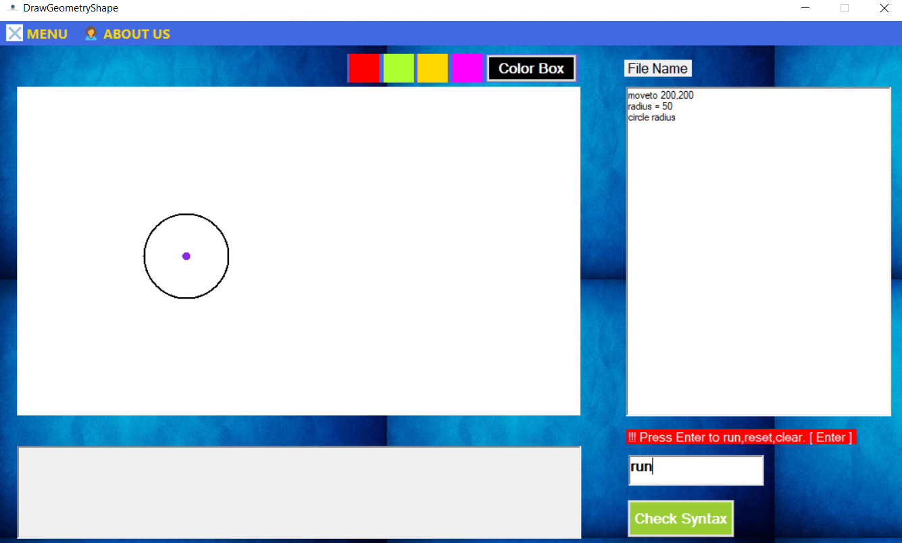

* Multiple circles are drawn while using the loop

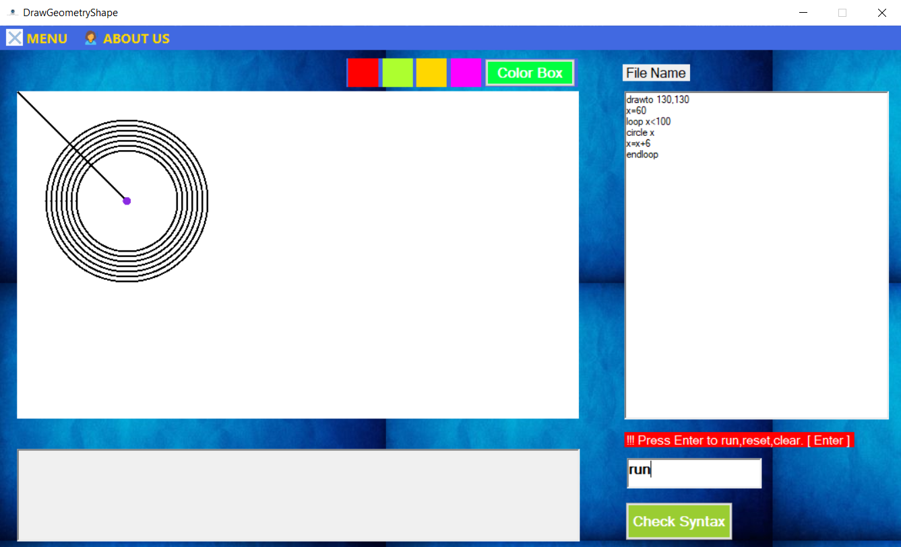

* Using if/endif statement:

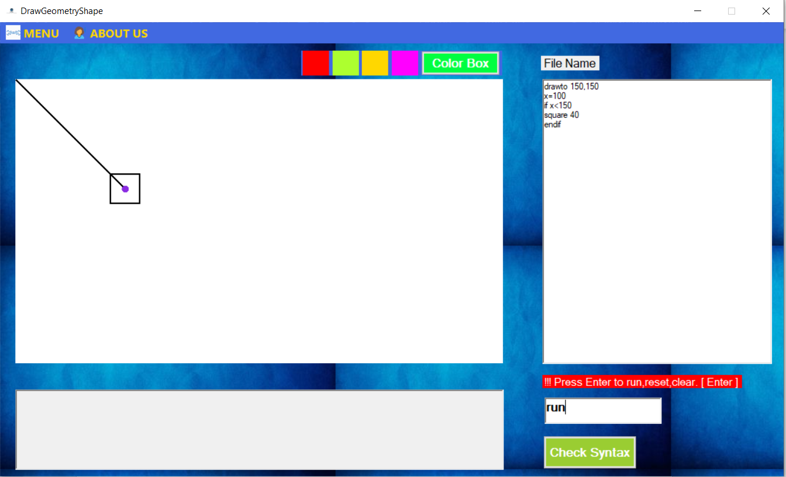

* Calling method

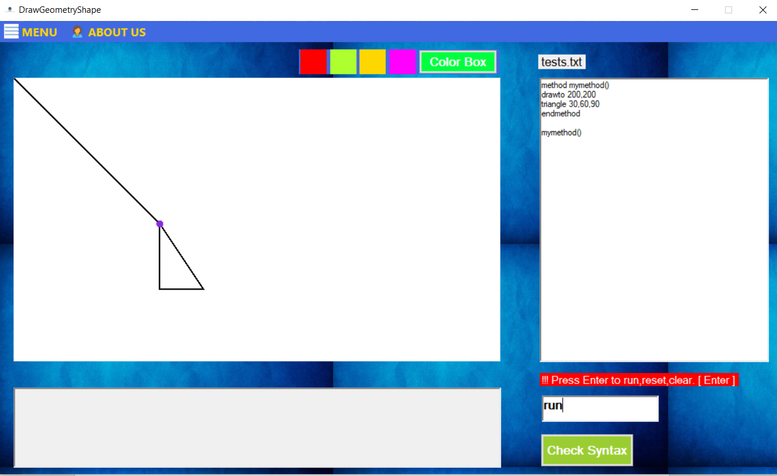

## **Reading from File**

* Open a file and read it

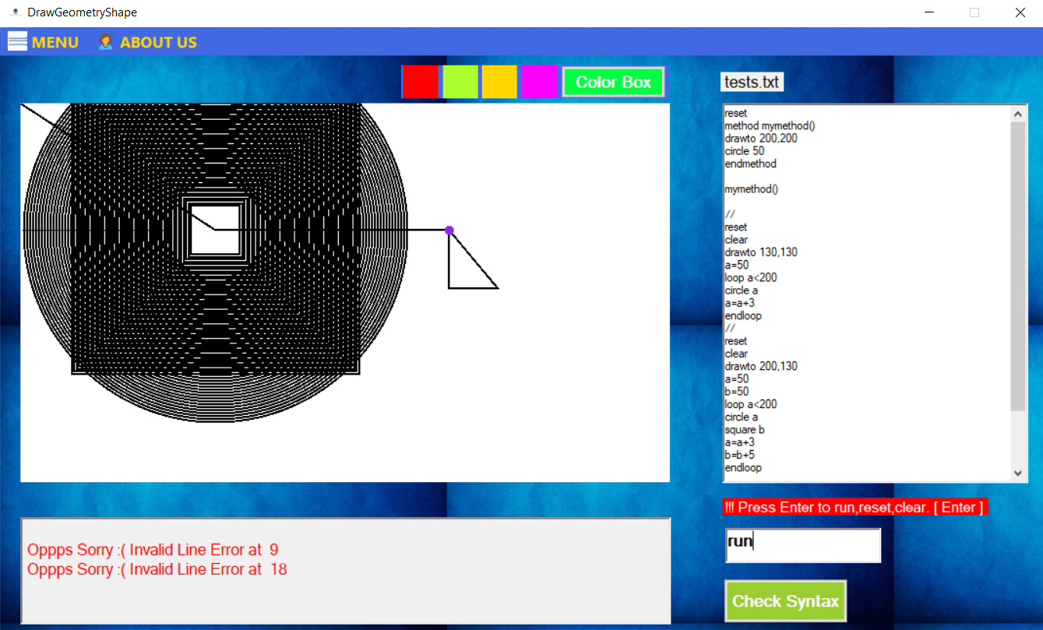

## **About Us**

